**Example work of Year 7 Autumn Term - Art  
PROJECT: Seven Ways of Creating an Illusion of Depth**

This drawing has been made from direct observation. The student has selected a viewpoint in the Art Studio and drawn the objects with in the space, creating an illusion of depth.

**Criteria for Success**

The drawing fills the paper.

The drawing was mapped out faintly to allow for corrections to be made.

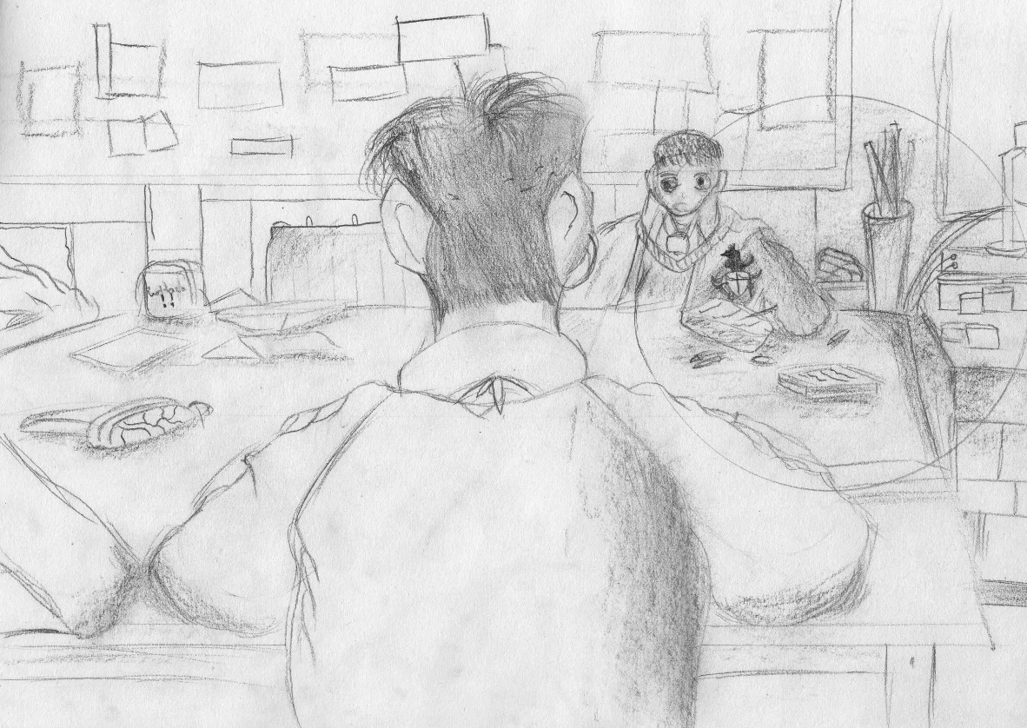

**Formative Feedback and an Assessment Mark is given to the final drawing**

The student only began to use tonal rendering skills and adding detail in the later stages of the drawing process.

The student has focussed on observing what they see and using “visual measuring” in order to correctly define the objects in the space.

The student has applied “the rules” of creating an illusion of depth on a two-dimensional surface.

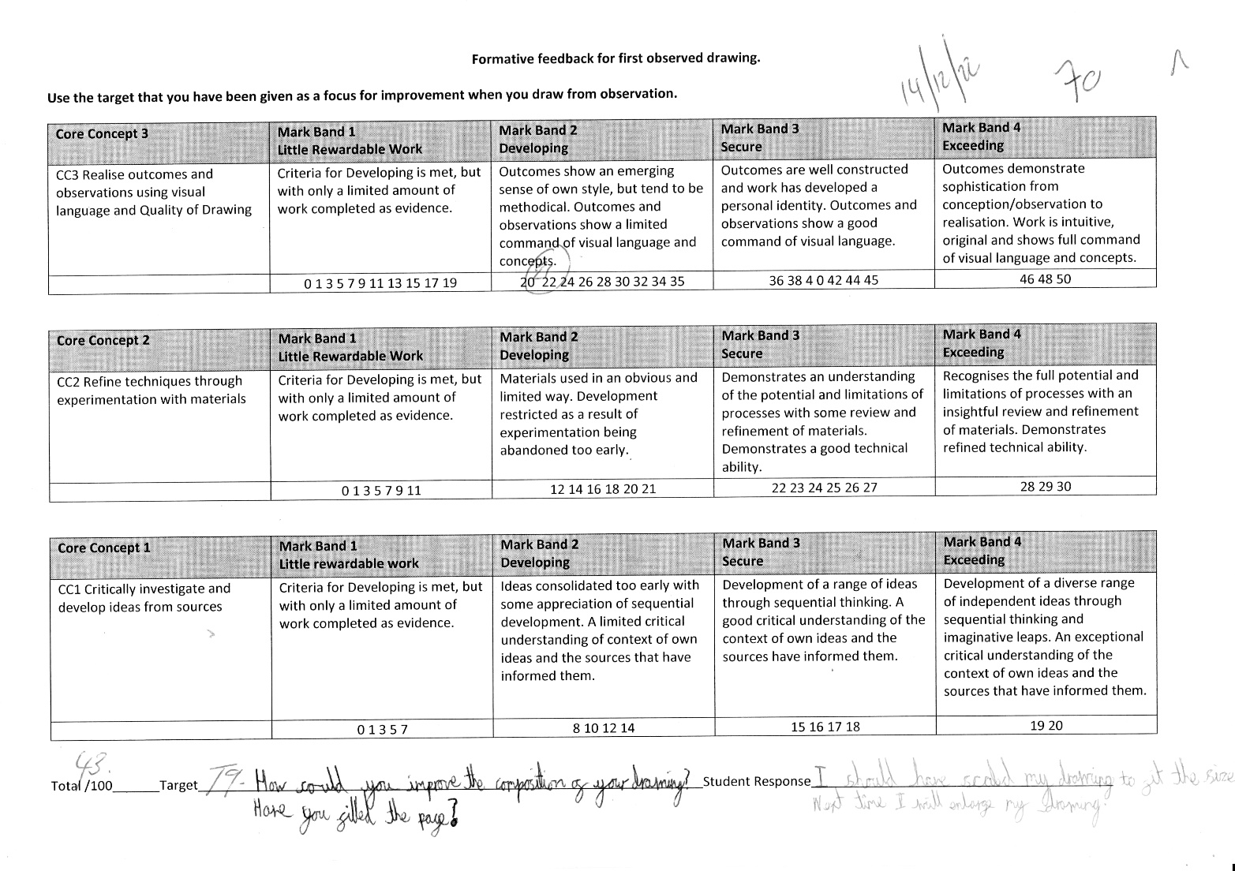

The student has reflected on how to use the target to improve their own drawing skills and has demonstrated improvement, using the feedback given by the teaching staff.

Formative feedback is given that the student responds to in written form.